EEG Signal Processing and Functional Connectivity Analysis

1. Introduction
Electroencephalography (EEG) provides a non-invasive method for recording electrical activity generated by the brain. Signal processing techniques can be used to examine the frequency composition of EEG signals and investigate functional relationships between different recording channels.
In this assignment, EEG preprocessing, spectral analysis, and functional connectivity measures were applied to the MNE sample dataset. The analyses focused particularly on the beta frequency band (14–30 Hz), using Power Spectral Density (PSD), Cross-Spectral Density (CSD), coherence, Phase Locking Value (PLV), and envelope correlation.

2. Objectives
The main objectives of this assignment were to:
- Load and preprocess EEG data using MNE-Python.
- Estimate spectral power using Welch and Multitaper methods.
- Calculate and visualize cross-spectral density between selected EEG channels.
- Estimate functional connectivity using coherence, PLV, and envelope correlation.
- Compare different connectivity measures and spectral estimation methods.
- Construct and visualize a functional connectivity network.

3. Dataset and Preprocessing

3.1 Dataset

The official MNE sample dataset was used for this analysis. The recording was loaded from the file sample_audvis_raw.fif.
The original recording contained 376 channels, including EEG, EOG, magnetometer, gradiometer, and stimulus channels. The sampling frequency was approximately 600.61 Hz, and the recording duration was approximately 277.72 seconds.
For the present analysis, EEG, EOG, and stimulus channels were selected, resulting in 70 channels: 60 EEG channels, one EOG channel, and nine stimulus channels.
One EEG channel (EEG 053) was marked as bad in the original dataset and excluded from subsequent EEG connectivity analyses. Therefore, 59 EEG channels were used for the functional connectivity calculations.

3.2 Electrode Locations and Montage
The original dataset contained three-dimensional electrode location information (X, Y, and Z coordinates) for the EEG channels. These coordinates were extracted from the original recording metadata and preserved throughout the analysis.
The standard_1020 montage was not applied. The EEG channels were identified by numerical labels (e.g., EEG 001, EEG 002), and a verified mapping between these labels and standard 10–20 electrode names was not available. Assigning standard 10–20 locations without such a mapping could result in incorrect electrode positions. Therefore, the original digitized coordinates were retained.

3.3 Filtering and Re-referencing
The following preprocessing steps were applied to the EEG channels:
- Notch filtering: A 60 Hz notch filter was applied to reduce power-line interference.
- Band-pass filtering: A 0.1–40 Hz FIR filter with a firwin design was applied to retain the relevant frequency range.
- Average referencing: The EEG signals were re-referenced using the average of the EEG channels.
Zero-phase filtering was used to minimize phase distortion introduced by the filtering process.

4. Spectral Analysis

4.1 Power Spectral Density (PSD)
PSD was estimated using two methods: Welch's method and the Multitaper method.
For Welch's method, a 2-second window and 1-second overlap were used. This approach divides the signal into overlapping segments, estimates the power spectrum for each segment, and averages the resulting estimates.
The Multitaper method was also applied to the selected channels, EEG 001 and EEG 002. Multiple orthogonal tapers are used in this method to reduce spectral estimation variance and spectral leakage.
The resulting PSD estimates were plotted as a function of frequency. Both methods provided information about the distribution of signal power across the frequency range.

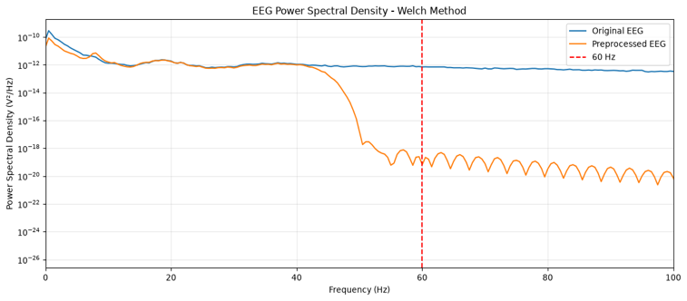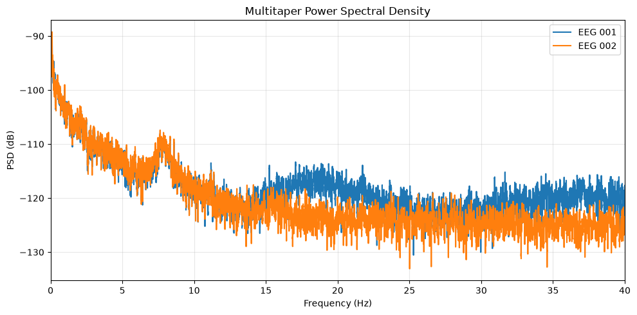

4.2 Cross-Spectral Density (CSD)
Cross-spectral density was calculated between EEG 001 and EEG 002 using Welch's method. A 2-second window with 1-second overlap was used.
The magnitude of the CSD was visualized across the frequency range. CSD describes the frequency-dependent relationship between two signals and contains information about their shared spectral activity and phase relationship.
Unlike coherence, the magnitude of CSD is not normalized and is therefore influenced by the power of the individual signals.

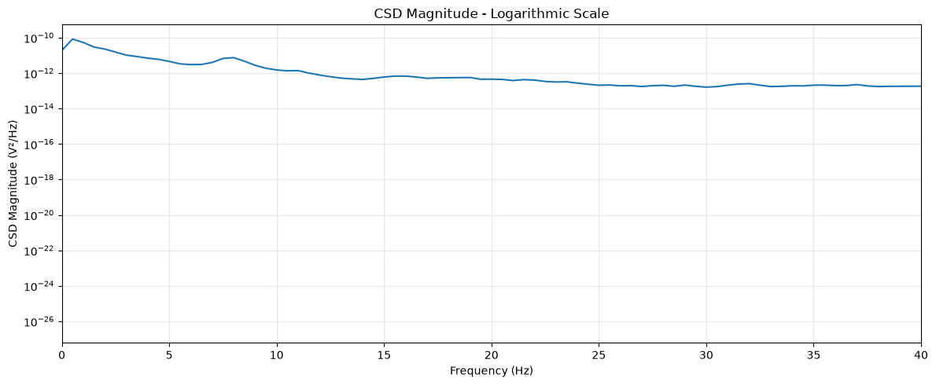

5. Functional Connectivity Analysis

5.1 Coherence
Coherence was calculated to investigate the frequency-dependent linear relationship between EEG 001 and EEG 002.
Welch coherence was estimated using 2-second segments with 1-second overlap. The coherence values ranged from approximately 0.027 to 0.982 across the analyzed frequency range.
The mean coherence values within the selected frequency bands were:

Frequency band | Mean coherence
Delta | 0.9750
Theta | 0.9404
Alpha | 0.8430
Beta | 0.2648
These results indicate that the selected channel pair exhibited higher average coherence in the lower-frequency bands than in the beta band.

5.2 Coherence Matrices: Welch and Multitaper
Functional connectivity was estimated across all 59 good EEG channels using both Welch coherence and MNE's Multitaper-based spectral connectivity method.
For the Multitaper analysis, fixed-length epochs of 2 seconds with 1-second overlap were created. This resulted in 276 epochs. Coherence was calculated in the beta frequency range (14–30 Hz), and the resulting connectivity matrix was represented as a 59 × 59 matrix.
Both methods produced symmetric connectivity matrices, with values representing the strength of coherence between channel pairs. The diagonal elements represent self-connectivity and were equal to 1.
The mean and median connectivity values, excluding the diagonal, were:

Measure | Welch | Multitaper
Mean coherence | 0.1223 | 0.2796
Median coherence | 0.0611 | 0.2282
The Mean Absolute Difference (MAD) between the two matrices, excluding the diagonal, was approximately 0.1573.
The Multitaper method produced higher average coherence values than Welch's method in this analysis. However, this difference should be interpreted in the context of the estimation procedures and their parameters rather than as evidence of greater physiological synchronization.
Potential reasons for the differences include the use of different spectral estimation approaches, tapering procedures, spectral smoothing, and averaging across segments or epochs.

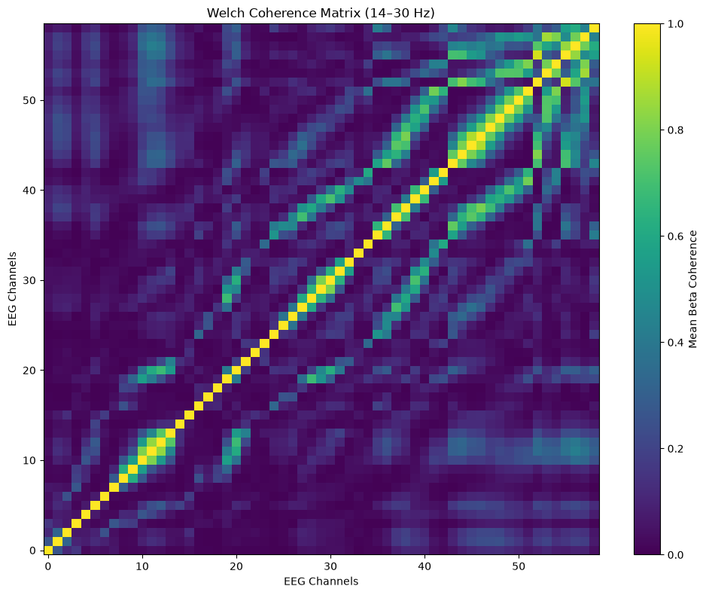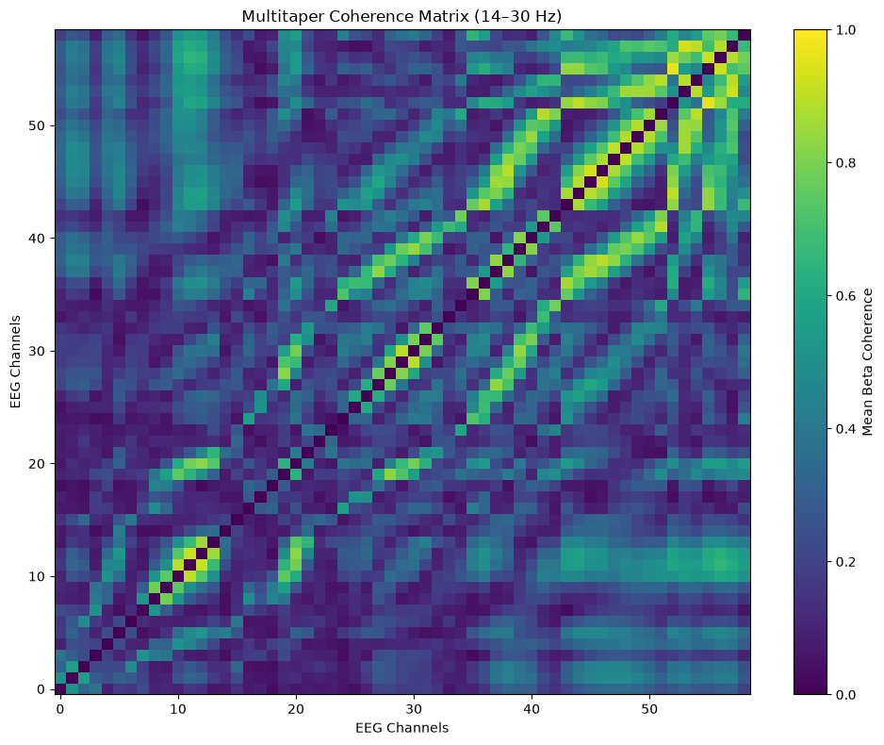

5.3 Coherence Over Time
To investigate temporal changes in connectivity, coherence between EEG 001 and EEG 002 was estimated using a sliding-window approach.
A 10-second analysis window with a 5-second step was used. Within each window, Welch coherence was calculated using 2-second segments with 1-second overlap.
A total of 54 windows were analyzed.
The temporal coherence values showed variation across the recording:
Statistic | Value
Mean | 0.3621
Standard deviation | 0.0627
Minimum | 0.2580
Maximum | 0.5424
These results demonstrate that coherence between the selected channels was not constant throughout the recording.
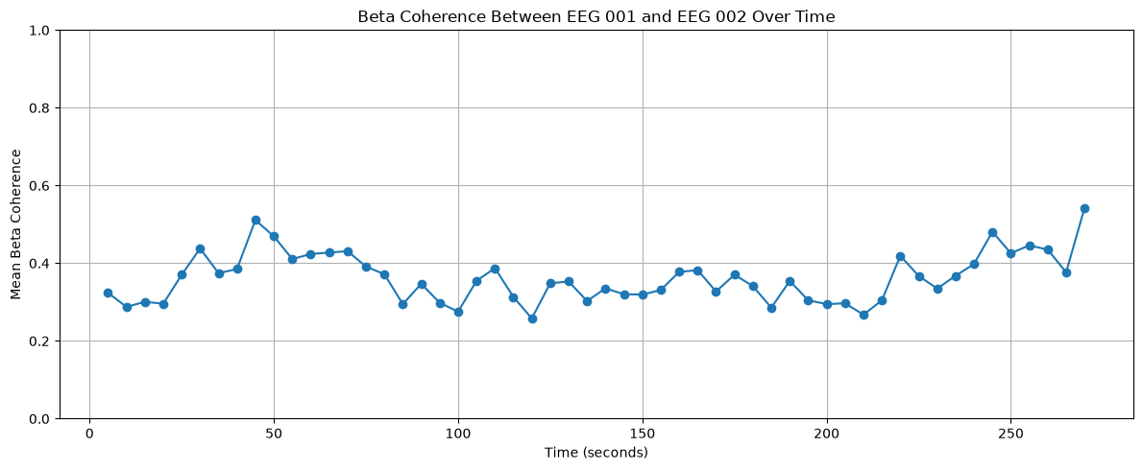

5.4 Effect of Window Length and Overlap
Window length and overlap influence spectral estimation and connectivity analysis.
Longer windows generally provide better frequency resolution because they contain more data points per segment. However, they result in fewer segments for averaging, which may increase the variability of the estimated spectrum.
Shorter windows provide poorer frequency resolution but allow more segments to be analyzed, potentially improving the stability of the averaged estimate.
Increasing overlap allows more segments to be included in the analysis and can produce smoother estimates. However, overlapping segments are not fully independent, and higher overlap also increases computational requirements.
In epoch-based Multitaper connectivity analysis, epoch duration affects the available frequency resolution, while the number of epochs and taper settings influence the stability and spectral smoothing of the estimates.

5.5 Phase Locking Value (PLV)
PLV was calculated to assess the consistency of phase differences between EEG channel pairs in the beta frequency band.
First, a fourth-order Butterworth band-pass filter was applied to the EEG signals between 14 and 30 Hz. The Hilbert transform was then used to obtain the analytic signals and extract instantaneous phase information.
To reduce potential edge effects, the first and last seconds of the filtered signals were excluded.
PLV was calculated for all pairs of the 59 EEG channels, resulting in a symmetric 59 × 59 connectivity matrix. The diagonal values were equal to 1 because each channel has a perfectly consistent phase relationship with itself.
The off-diagonal PLV values showed the following distribution:

Statistic | Value
Mean | 0.2232
Median | 0.1784
Minimum | 0.0063
Maximum | 0.9218
PLV measures the consistency of phase differences over time. Higher values indicate more consistent phase relationships between two signals.
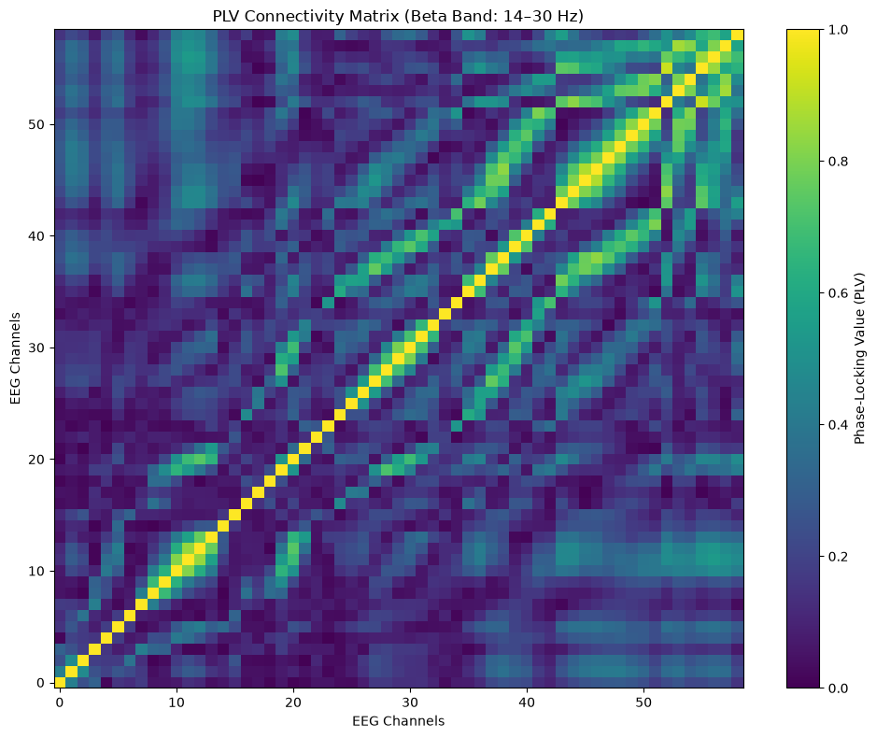

5.6 Envelope Correlation
Envelope correlation was used to examine the relationship between fluctuations in the amplitude of beta-band activity.
The analytic signal was obtained using the Hilbert transform, and its absolute value was calculated to extract the instantaneous amplitude envelope. The first and last seconds were excluded to reduce edge effects.
Pearson correlation coefficients were then calculated between the amplitude envelopes of all pairs of EEG channels.
The resulting matrix was symmetric and had dimensions of 59 × 59. Its values ranged from approximately -0.0294 to 1.0000.
Positive values indicate that the amplitude envelopes of two channels tend to increase and decrease together. Negative values indicate an inverse relationship, whereas values near zero suggest a weak linear relationship between their amplitude fluctuations.

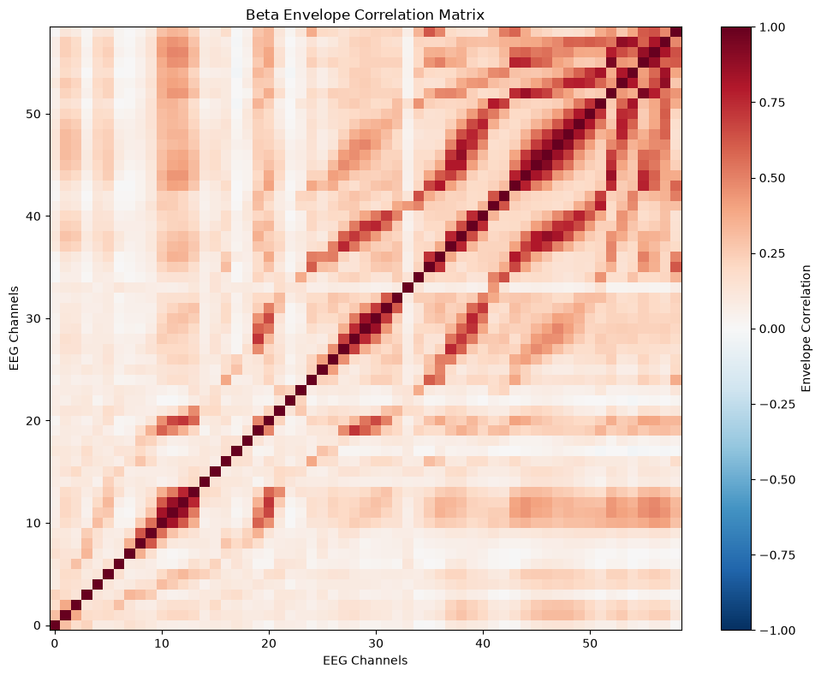

5.7 Comparison of Coherence, PLV, and Envelope Correlatio
Although coherence, PLV, and envelope correlation are all used to investigate functional relationships between EEG signals, they measure different aspects of signal interaction.
- Coherence measures frequency-specific linear relationships between two signals and reflects both amplitude and phase relationships in the cross-spectrum.
- PLV measures the consistency of phase differences between two signals over time, independently of their amplitude.
- Envelope correlation measures the correlation between fluctuations in the amplitude envelopes of two signals.
These measures may show similar connectivity patterns when both phase relationships and amplitude fluctuations are coordinated. However, they may also differ.
For example, two signals may exhibit a consistent phase relationship without having strongly correlated amplitude envelopes. Similarly, their amplitude envelopes may fluctuate together even when their instantaneous phase differences are not consistent.
Therefore, these measures provide complementary information and should not be interpreted as interchangeable indicators of functional connectivity.
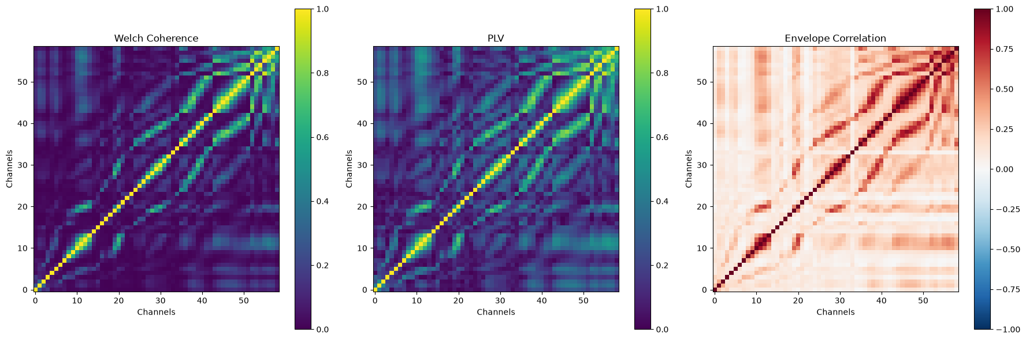

5.8 Covariance and Correlation in the Beta Band
Covariance and Pearson correlation were calculated for the beta-band signals of EEG 001 and EEG 002.
The signals were selected from the beta-filtered EEG data (14–30 Hz), and the two measures were calculated using the same channel pair.

The results were:
Measure | Value
Beta-band covariance | 5.444 × 10⁻¹²
Beta-band correlation | 0.5084
The positive covariance indicates that the two beta-band signals tend to vary in the same direction. The Pearson correlation coefficient of approximately 0.51 indicates a moderate positive linear relationship between the selected signals.
Covariance depends on the scale and units of the signals, whereas correlation is normalized and ranges from -1 to +1. Therefore, correlation is more suitable for comparing the strength and direction of linear relationships across different signal pairs.
Importantly, a positive correlation does not necessarily indicate direct neural communication or a causal relationship between the underlying brain sources.

6. Functional Network Construction
A functional connectivity network was constructed using the PLV matrix.
A threshold of 0.30 was selected to retain stronger phase-based connections. Values below this threshold were removed, while values above the threshold were retained as weighted edges.
The resulting network contained 59 nodes and 427 undirected edges, with a network density of approximately 0.250.
A circular layout was used to visualize the network. Edge widths were scaled according to the corresponding PLV values, allowing stronger connections to appear more prominent.
The nodes represented EEG recording channels, and the edges represented functional relationships between channel pairs. The channel with the highest degree was EEG 058, with 29 connections, followed by EEG 012, with 28 connections.
The network represents functional connectivity between scalp recording channels rather than direct anatomical connections between brain regions. In addition, the selected threshold influences network density and the number of retained connections.

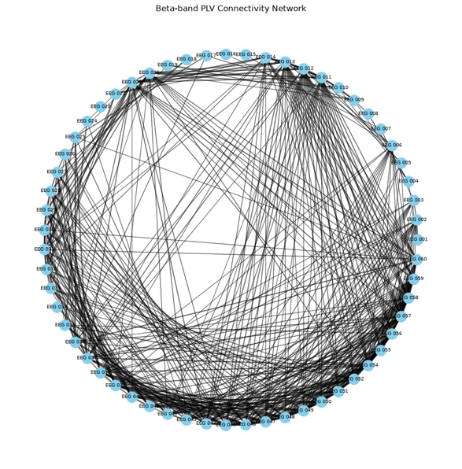

7. Discussion
This assignment demonstrated several approaches for investigating EEG spectral characteristics and functional connectivity.
The PSD analysis provided information about the distribution of signal power across frequencies, while CSD described the frequency-dependent relationship between two selected channels.
The comparison between Welch and Multitaper coherence showed that different spectral estimation approaches can produce different connectivity estimates. In this dataset, Multitaper coherence produced higher average beta-band values than Welch coherence. These differences may be related to tapering, spectral smoothing, and averaging procedures.
The PLV analysis provided information about phase synchronization in the beta band, whereas envelope correlation focused on the relationship between amplitude fluctuations. Their complementary nature highlights the importance of using multiple connectivity measures when examining EEG signals.
The covariance and correlation results for EEG 001 and EEG 002 indicated a moderate positive linear relationship between their beta-band signals. However, these findings should be interpreted cautiously because scalp EEG connectivity measures can be influenced by common sources, volume conduction, and the reference scheme.
Finally, the functional network visualization provided a graphical representation of the stronger phase-based relationships between EEG channels. The network structure depended on the selected PLV threshold and should therefore be interpreted as one representation of the connectivity data rather than a definitive description of brain organization.

8. Limitations
Several limitations should be considered when interpreting the results:
- The EEG channels were identified using numerical labels, and a verified mapping to standard 10–20 electrode names was not available. Therefore, the original three-dimensional electrode coordinates were retained instead of applying the standard_1020 montage.
- Connectivity estimates can be influenced by volume conduction, common sources, and the EEG reference scheme.
- The comparison between Welch and Multitaper coherence involved different estimation procedures and averaging strategies. Therefore, differences between the resulting matrices should not be attributed to a single parameter.
- The functional network was constructed using a selected PLV threshold of 0.30. Different thresholds could produce different network densities and topologies.
- The analysis was performed on one recording from the MNE sample dataset; therefore, the results should not be generalized to a broader population.

9. Conclusion
In this assignment, EEG preprocessing, spectral analysis, and multiple functional connectivity measures were implemented using Python and MNE-Python.
Welch and Multitaper methods were used to estimate spectral power and coherence. PLV and envelope correlation provided complementary information about phase synchronization and amplitude co-fluctuation in the beta frequency band.
The comparison of these methods demonstrated that functional connectivity depends on the measure and estimation parameters used. Finally, a threshold-based functional network was constructed to visualize stronger phase-based relationships between EEG channels.
Overall, this assignment provided practical experience with EEG signal processing, spectral estimation, functional connectivity analysis, and network visualization.

